**MANAGING CHANGE**

Change management is a structured approach for ensuring that changes are thoroughly and smoothly implemented within organizations, and that the lasting benefits of change are achieved. The focus is on the wider impacts of change, particularly on people and how they, as individuals and teams, move from the current situation to the new one. The change in question could range from a simple process change, to major changes in policy or strategy needed if the organization is to achieve its potential. In the modern business environment, organizations face rapid changes like never before. Globalization and the constant innovation of technology result in a constantly evolving business environment that requires organizations to adapt very fast and change constantly to meet the changing needs of consumers.

Phenomena such as [social media](http://en.wikipedia.org/wiki/Social_media) and mobile adaptability have revolutionized business and the effect of this is an ever increasing need for change. The growth in technology also has a secondary effect of increasing the availability and therefore accountability of knowledge. Easily accessible information has resulted in unprecedented scrutiny from stockholders and the media. Prying eyes and listening ears raise the stakes for failed business endeavors and increase the pressure on struggling executives to manage change well. With the business environment experiencing so much change, organizations must then learn to become comfortable with change as well. The fact that many people fear the uncertainty of change can cause resistance and inhibit innovation in organizations.

Organizational change is a process led by the HR department to ensure a structured approach in an organization for ensuring that changes are smoothly and successfully implemented to achieve lasting benefits or everyone. The ability to successfully manage and adapt to organizational change is an essential ability required in the workplace today and is very key to entrepreneurial success

Modern organizational change is largely motivated by exterior innovations rather than internal motives. When these new developments occur, the organizations that adapt quickest create a competitive advantage for themselves, while the companies that resist change get left behind. This can result in drastic profit and/or market share losses.

Organizational change directly affects all departments from the entry level employee to senior management. The entire company must learn how to handle changes to the organization.

When determining which of the latest techniques or innovations to adopt, there are four major factors to be considered:

1. Levels, goals, and strategies
2. Measurement system
3. Sequence of steps
4. Implementation and organizational change

Regardless of the many types of organizational change, the critical aspect is a company’s ability to win the buy-in of their organization’s employees on the change. Effectively managing organizational change is a four-step process that involves:

1. Recognizing the changes in the broader business environment.
2. Developing the necessary adjustments needed to meet company’s needs.
3. Training employees on the appropriate changes needed
4. Winning the support of the employees with the persuasiveness of the appropriate adjustments.

-Organizational change management should begin with a systematic diagnosis of the current situation in order to determine both the need for change and the capability to change. The objectives, content, and process of change should all be specified as part of a Change Management plan.

-Change management processes may include creative marketing to enable communication between changing audiences, as well as deep social understanding about leadership’s styles and group dynamics. Organized Change Management aligns groups’ expectations, communicates, integrates teams and manages people training. It makes use of performance metrics, such as financial results, operational efficiency, leadership commitment, communication effectiveness, and the perceived need for change to design appropriate strategies, in order to avoid change failures or resolve troubled change projects.

Successful change management is more likely to occur if the following are included]

1. Define measurable stakeholder aims, create a business case for their achievement (which should be continuously updated), and monitor assumptions, risks, dependencies, costs, return on investment, dis-benefits and cultural issues affecting the progress of the associated work
2. Effective communications that informs various stakeholders of the reasons for the change (why?), the benefits of successful implementation (what is in it for us, and you) as well as the details of the change (when? where? who is involved? how much will it cost? etc.)
3. Devise an effective education, training and/or skills upgrading scheme for the organization
4. Counter resistance from the employees of companies and align them to overall strategic direction of the organization
5. Provide personal counseling (if required) to alleviate any change-related fears
6. Monitoring of the implementation and fine-tuning as required

Sequence followed in generic change management strategy

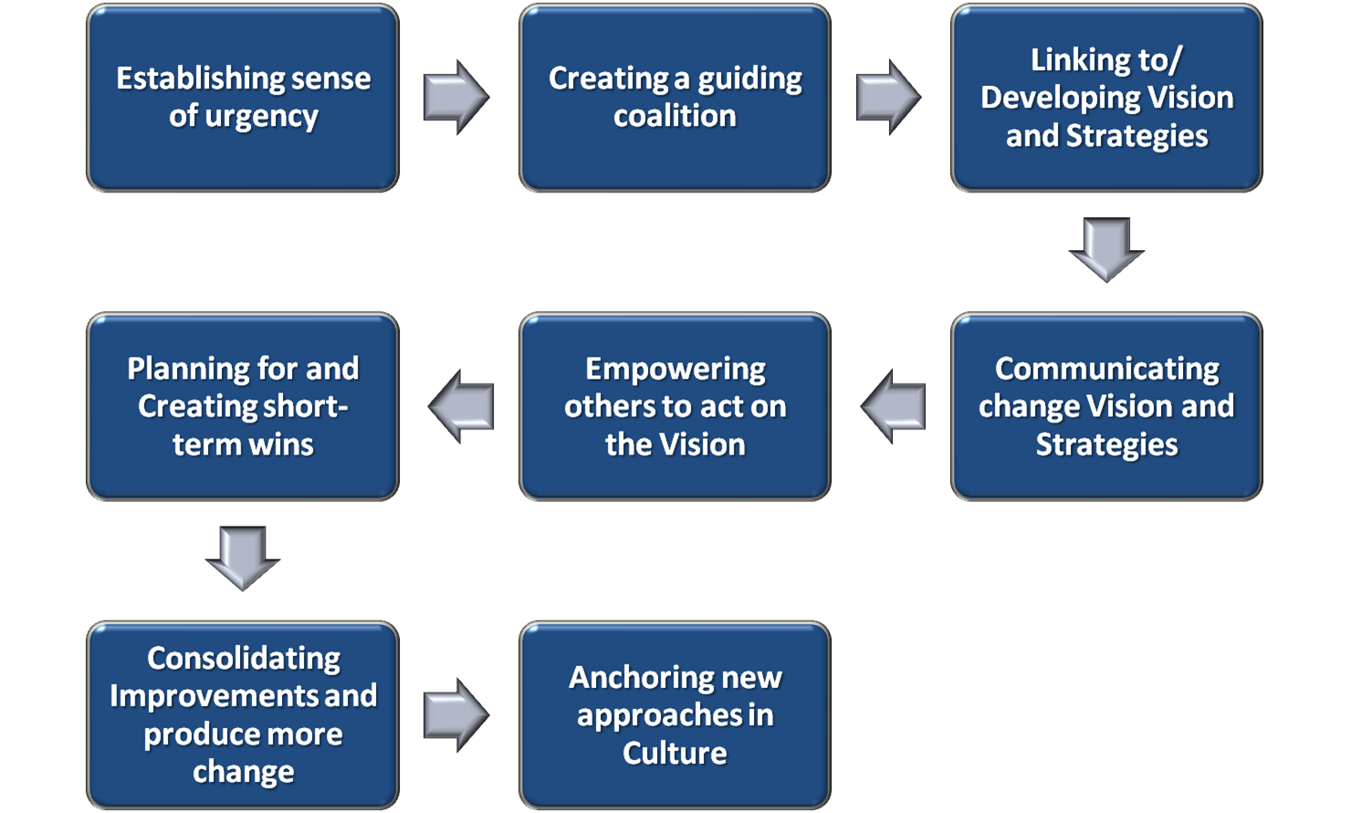

The change management process is the sequence of steps or activities that a change management team or [project](http://www.change-management.com/tutorial-change-process-detailed.htm) leader would follow to apply change management to a project or change. Based on Prosci's research of the most effective and commonly applied change, most change management processes contain the following three phases:

**Phase 1 - Preparing for change**(Preparation, assessment and strategy development)

**Phase 2 - Managing change** (Detailed planning and change management implementation)

**Phase 3 - Reinforcing change**(Data gathering, corrective action and recognition)

These phases result in the following approach as shown below in Figure 1.

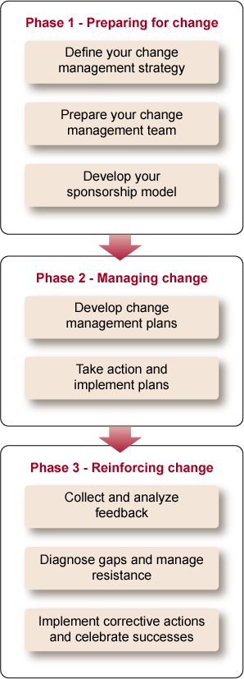  
Figure 1 - Change Management Process (the [Change Management Toolkit](http://www.change-management.com/change-management-toolkit.htm) and [Change Management Pilot](http://www.change-management.com/cm-pilot.htm) show you how to apply the process))

**Readiness assessments**

Assessments are tools used by a change management team or project leader to assess the organization's readiness to change. Readiness assessments can include organizational assessments, culture and history assessments, employee assessments, sponsor assessments and change assessments. Each tool provides the project team with insights into the challenges and opportunities they may face during the change process.

* Assess the scope of the change, including: How [big](http://www.change-management.com/tutorial-change-process-detailed.htm) is this change? How many people are affected? Is it a gradual or radical change?
* Assess the readiness of the organization impacted by the change, including: What is the value- system and background of the impacted groups? How much change is already going on? What type of resistance can be expected?
* Assess the strengths of your change management team.
* Assess the change sponsors and take the first steps to enable them to effectively lead the change process.

### Communication and communication planning

Many managers assume that if they communicate clearly with their employees, their job is done. However, there are many reasons why employees may not hear or understand what their managers are saying the first time around. In fact, you may have heard that messages need to be repeated 6 to 7 times before they are cemented into the minds of employees. That is because each employee’s readiness to hear depends on many factors. Effective communicators carefully consider three components: the audience, what is said and when it is said.

For example, the first step in managing change is building awareness around the need for change and creating a desire among employees. Therefore, initial communications are typically designed to create awareness around the business reasons for change and the risk of not changing. Likewise, at each step in the process, communications should be designed to share the right messages at the right time.

Communication planning, therefore, begins with a careful analysis of the audiences, key messages and the timing for those messages. The change management team or project leaders must design a communication plan that addresses the needs of front-line employees, supervisors and executives. Each audience has particular needs for information based on their role in the implementation of the change.

### Coaching and manager training for change management

Supervisors will play a key role in managing change. Ultimately, the direct supervisor has more influence over an employee’s motivation to change than any other person at work. Unfortunately, supervisors as a group can be the most difficult to convince of the need for change and can be a source of resistance. It is vital for the change management team and executive sponsors to gain the support of supervisors and to build change leadership. Individual change management activities should be used to help these supervisors through the change process.

Once managers and supervisors are on board, the change management team must prepare a coaching strategy. They will need to provide training for supervisors including how to use individual change management tools with their employees.

### Training and training development

Training is the cornerstone for building knowledge about the change and the required skills. Project team members will develop training requirements based on the skills, knowledge and behaviors necessary to implement the change. These training requirements will be the starting point for the training group or the project team to develop training programs.

### Sponsor activities and sponsor roadmaps

Business leaders and executives play a critical sponsor role in change management. The change management team must develop a plan for sponsor activities and help key business leaders carry out these plans. Sponsorship should be viewed as the most important success factor. Avoid confusing the notion of sponsorship with support. The CEO of the company may support your project, but that is not the same as sponsoring your initiative.

Sponsorship involves active and visible participation by senior business leaders throughout the process. Unfortunately many executives do not know what this sponsorship looks like. A change agent's or project leader's role includes helping senior executives do the right things to sponsor the project.

### Resistance management

Resistance from employees and managers is normal. Persistent resistance, however, can threaten a project. The change management team needs to identify, understand and manage resistance throughout the organization. Resistance management is the processes and tools used by managers and executives with the support of the project team to manage employee resistance.

### Data collection, feedback analysis and corrective action

Employee involvement is a necessary and integral part of managing change. Managing change is not a one way street. Feedback from employees is a key element of the change management process. Analysis and corrective action based on this feedback provides a robust cycle for implementing change.

### Celebrating and recognizing success

Early successes and long-term wins must be recognized and celebrated. Individual and group recognition is also a necessary component of change management in order to cement and reinforce the change in the organization.

The final step in the change management process is the after-action review. It is at this point that you can stand back from the entire program, evaluate successes and failures, and identify process changes for the next project. This is part of the ongoing, continuous improvement of change management for your organization and ultimately leads to change competency.